**Lab 1a**

**package** main;

**public** **class** Vehicle {

**private** String tenChuXe,loaiXe;

**private** **int** dungTich;

**private** **double** triGia;

**public** Vehicle(String tenChuXe, String loaiXe, **int** dungTich, **double** triGia) {

**super**();

**this**.tenChuXe = tenChuXe;

**this**.loaiXe = loaiXe;

**this**.dungTich = dungTich;

**this**.triGia = triGia;

}

**public** Vehicle(){

}

**public** **double** tinhThue(){

**double** thue;

**if**(dungTich<100) thue=triGia*0.01;

**else** **if** (dungTich >= 100 && dungTich<=200) thue = triGia * 0.03;

**else** thue = triGia * 0.05;

**return** thue;

}

**public** String getTenChuXe() {

**return** tenChuXe;

}

**public** **void** setTenChuXe(String tenChuXe) {

**this**.tenChuXe = tenChuXe;

}

**public** String getLoaiXe() {

**return** loaiXe;

}

**public** **void** setLoaiXe(String loaiXe) {

**this**.loaiXe = loaiXe;

}

**public** **int** getDungTich() {

**return** dungTich;

}

**public** **void** setDungTich(**int** dungTich) {

**this**.dungTich = dungTich;

}

**public** **double** getTriGia() {

**return** triGia;

}

**public** **void** setTriGia(**double** triGia) {

**this**.triGia = triGia;

}

@Override

**public** String toString() {

**return** tenChuXe + "-"+loaiXe + "-"+dungTich + "-"+triGia + "-";

}

**void** inThue(){

System.***out***.printf("%5s %15s %15d %15.2f %10.2f\n",tenChuXe,loaiXe,dungTich,triGia,tinhThue());

}

}

**package** main;

**import** java.util.Scanner;

**public** **class** test {

**static** Scanner *sc* = **new** Scanner(System.***in***);

**static** **void** nhapXe(Vehicle xe){

System.***out***.print("Nhap ten chu xe:");

*sc*.nextLine();

xe.setTenChuXe(*sc*.nextLine());

System.***out***.print("Nhap loai xe :");

xe.setLoaiXe(*sc*.nextLine());

System.***out***.print("Nhap dung tich xe: ");

xe.setDungTich(*sc*.nextInt());

System.***out***.print("Nhap tri gia xe: ");

xe.setTriGia(*sc*.nextDouble());;*sc*.nextLine();

}

**public** **static** **void** main(String[] args) {

Vehicle v[]= **null**;

**int** a,n=0;

**boolean** flag = **true**;

**do**{

System.***out***.println("------Vui long chon chuc nang-----");

System.***out***.println("1.Tao doi tuong va nhap thong tin.\n"+

"2.Xuat ban ke khai tien thue.\n"+

"3.Thoat chuong trinh.\n");

System.***out***.print("Nhap lua chon cua ban : ");

a =*sc*.nextInt();

**switch** (a){

**case** 1:

System.***out***.print("Nhap so luong xe ban muon khai bao thue : ");

n=*sc*.nextInt();

v= **new** Vehicle[n];

**for** (**int** i = 0; i < n; i++) {

System.***out***.println("Xe thu " + (i+1));

v[i] = **new** Vehicle();

*nhapXe*(v[i]);

}

**break**;

**case** 2:

System.***out***.println("Ten chu xe Loai xe Dung tich Tri gia Thue");

System.***out***.println("================================================================");

**for** (**int** i = 0; i < n; i++) {

v[i].inThue();

}

**break**;

}

}**while** (flag);

}

}

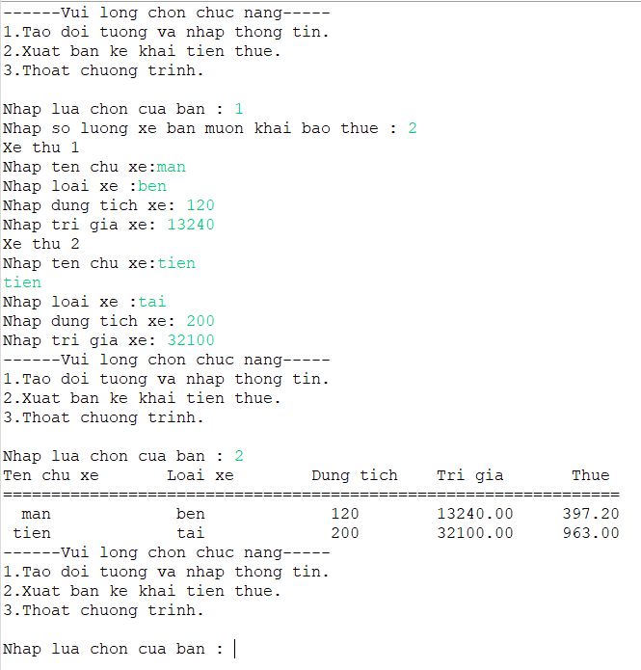

**Lab 1b**

**package** main;

**import** java.text.NumberFormat;

**import** java.text.SimpleDateFormat;

**import** java.util.Calendar;

**import** java.util.Date;

**import** java.util.Locale;

**public** **class** HangThucPham {

**private** **int** maHang;

**private** String tenHang;

**private** String ghiChu;

**private** **double** donGia;

**private** Date nSX, nHH;

**public** HangThucPham(**int** maHang, String tenHang, String ghiChu, **double** donGia, Date nSX, Date nHH) {

**this**.maHang = maHang;

**this**.tenHang = tenHang;

**this**.donGia = donGia;

**this**.nSX = nSX;

**this**.nHH = nHH;

**this**.ghiChu = ghiChu;

}

**public** HangThucPham() {

}

**public** **int** getMaHang() {

**return** maHang;

}

**public** **void** setMaHang(**int** maHang) {

**this**.maHang = maHang;

}

**public** String getTenHang() {

**return** tenHang;

}

**public** **void** setTenHang(String tenHang) {

**this**.tenHang = tenHang;

}

**public** **double** getDonGia() {

**return** donGia;

}

**public** **void** setDonGia(**double** donGia) {

**this**.donGia = donGia;

}

**public** Date getnSX() {

**return** nSX;

}

**public** **void** setnSX(Date nSX) {

**this**.nSX = nSX;

}

**public** Date getnHH() {

**return** nHH;

}

**public** **void** sethSD(Date nHH) {

**this**.nHH = nHH;

}

**public** String getGhiChu() {

**return** ghiChu;

}

**public** **void** setGhiChu(String ghiChu) {

**this**.ghiChu = ghiChu;

}

@Override

**public** String toString() {

SimpleDateFormat simpleDateFormat = **new** SimpleDateFormat("dd/MM/yyyy");

String str1 = simpleDateFormat.format(nSX);

String str2 = simpleDateFormat.format(nHH);

**return** "Thong tin ve san pham \n" +

"Ma hang : " + maHang +

"\nTen hang : " + tenHang +

"\nDon gia : " + donGia +

"\nNgay san xuat : " + str1 +

"\nNgay het han : " + str2 +

"\nGhi chu : " + ghiChu

;

}

**public** **void** setNSX(**int** year, **int** month, **int** day) {

Calendar calendar = Calendar.*getInstance*();

calendar.set(year, month - 1, day);

**this**.nSX = calendar.getTime();

}

**public** **void** setHSD(**int** year, **int** month, **int** day) {

Calendar calendar = Calendar.*getInstance*();

calendar.set(year, month - 1, day);

**this**.nHH = calendar.getTime();

}

**public** **boolean** kiemTraTenHang(**boolean** k) {

**if** (**this**.tenHang == "" || **this**.tenHang.isEmpty()) {

System.***out***.println("Ten hang khong duoc de trong : ");

} **else** {

k = **false**;

}

**return** k;

}

**public** **boolean** kiemTraNgay(**boolean** t) {

**if** (**this**.getnSX().compareTo(**this**.getnHH()) < 0) {

t = **false**;

} **else** {

System.***out***.println("Ngay het han khong duoc nho hon ngay san xuat : ");

}

**return** t;

}

**public** **void** kiemTraNgayHH() {

Date today = **new** Date();

today.getTime();

SimpleDateFormat simpleDateFormat = **new** SimpleDateFormat("dd/MM/yyyy");

String st = simpleDateFormat.format(today);

**if** (**this**.getnHH().compareTo(today) < 0) {

System.***out***.println("Hom nay la ngay " + st + ", hang hoa da het han ");

} **else** {

System.***out***.println("Hom nay la ngay " + st + ", hang hoa van con han ");

}

}

}

**package** main;

**import** java.util.Scanner;

**public** **class** test1b {

**public** **static** **void** main(String[] args) {

**try** (Scanner scanner = **new** Scanner(System.***in***)) {

HangThucPham tp1 = **new** HangThucPham();

**boolean** kt = **true**;

**boolean** th = **true**;

System.***out***.print("Nhap ma hang : ");

tp1.setMaHang(scanner.nextInt());

scanner.nextLine();

**do** {

System.***out***.print("Nhap ten hang : ");

tp1.setTenHang(scanner.nextLine());

} **while** (tp1.kiemTraTenHang(kt));

System.***out***.print("Nhap don gia : ");

tp1.setDonGia(scanner.nextDouble());

**do** {

System.***out***.print("Nhap nam,thang,ngay san xuat : ");

tp1.setNSX(scanner.nextInt(), scanner.nextInt(), scanner.nextInt());

System.***out***.print("Nhap nam,thang,ngay het han : ");

tp1.setHSD(scanner.nextInt(), scanner.nextInt(), scanner.nextInt());

System.***out***.print("Nhap ghi chu : "); scanner.nextLine();

tp1.setGhiChu(scanner.nextLine());

} **while** (tp1.kiemTraNgay(th));

System.***out***.println(tp1);

tp1.kiemTraNgayHH();

}

}

}

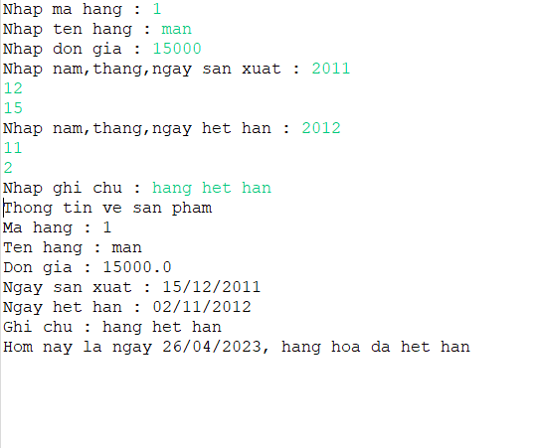

**Lab 2**

**package** bai2;

**public** **class** SinhVien {

String MaSv;

String Hoten;

**public** SinhVien(String MaSv, String Hoten) {

**this**.MaSv=MaSv;

**this**.Hoten=Hoten;

}

**public** SinhVien() {

}

**public** String getMaSv() {

**return** MaSv;

}

**public** **void** setMaSv(String maSv) {

MaSv = maSv;

}

**public** String getHoten() {

**return** Hoten;

}

**public** **void** setHoten(String hoten) {

Hoten = hoten;

}

@Override

**public** String toString() {

**return** "SinhVien [MaSv=" + MaSv + ", Hoten=" + Hoten + "]";

}

}

**package** bai2;

**import** java.util.ArrayList;

**import** java.util.Arrays;

**public** **class** LopHocPhan **extends** SinhVien {

**private** String maLHP;

**private** String tenLHP;

**private** String tenGV;

**private** String thongTinLopHoc;

**private** SinhVien[] dsSinhVien = **new** SinhVien[0];

**public** LopHocPhan(String maLHP, String tenLHP, String tenGV, String thongTinLopHoc, SinhVien[] dsSinhVien) {

**this**.maLHP = maLHP;

**this**.tenLHP = tenLHP;

**this**.tenGV = tenGV;

**this**.thongTinLopHoc = thongTinLopHoc;

**this**.dsSinhVien = dsSinhVien;

}

**public** LopHocPhan() {

**this**.maLHP = "";

**this**.tenLHP = "";

**this**.tenGV = "";

**this**.thongTinLopHoc = "";

**this**.dsSinhVien = **new** SinhVien[0];

}

**public** LopHocPhan(String MaSv, String Hoten, String maLHP, String tenLHP, String tenGV,

String thongTinLopHoc, SinhVien[] dsSV) {

}

**public** String getMaLHP() {

**return** maLHP;

}

**public** **void** setMaLHP(String maLHP) {

**this**.maLHP = maLHP;

}

**public** String getTenLHP() {

**return** tenLHP;

}

**public** **void** setTenLHP(String tenLHP) {

**this**.tenLHP = tenLHP;

}

**public** String getTenGV() {

**return** tenGV;

}

**public** **void** setTenGV(String tenGV) {

**this**.tenGV = tenGV;

}

**public** String getThongTinLopHoc() {

**return** thongTinLopHoc;

}

**public** **void** setThongTinLopHoc(String thongTinLopHoc) {

**this**.thongTinLopHoc = thongTinLopHoc;

}

**public** SinhVien[] getDsSinhVien() {

**return** dsSinhVien;

}

**public** **void** setDsSinhVien(SinhVien[] dsSinhVien) {

**this**.dsSinhVien = dsSinhVien;

}

@Override

**public** String toString() {

String result = "MaLHP: " + **this**.maLHP + "\n";

result += "TenLHP: " + **this**.tenLHP + "\n";

result += "GvGiangDay: " + **this**.tenGV + "\n";

result += "Thongtinbuoihoc: " + **this**.thongTinLopHoc + "\n";

result += "Danh sach sinh vien:\n";

**for** (SinhVien sv : **this**.dsSinhVien) {

result += sv.getMaSv() + "|" + sv.getHoten() + "\n";

}

result += "Tong so sinh vien: " + **this**.dsSinhVien.length + "\n";

**return** result;

}

}

**package** bai2;

**import** java.util.ArrayList;

**import** java.util.List;

**import** java.util.Scanner;

**public** **class** Main {

**public** **static** **void** main(String[] args) {

Scanner sc = **new** Scanner(System.***in***);

List<LopHocPhan> dsLopHocPhan = **new** ArrayList<>();

**while** (**true**) {

System.***out***.println("Chọn chức năng:");

System.***out***.println("1. Nhập thông tin");

System.***out***.println("2. Xuất thông tin");

System.***out***.println("0. Thoát");

**int** choice = sc.nextInt();

**switch** (choice) {

**case** 1:

System.***out***.println("Nhap thong tin lop hoc phan:");

System.***out***.print("Tong so sinh vien: ");

**int** tongSoSV = sc.nextInt();

sc.nextLine();

System.***out***.print("Ma LHP: ");

String maLHP = sc.nextLine();

System.***out***.print("Ten LHP: ");

String tenLHP = sc.nextLine();

System.***out***.print("Ten giang vien: ");

String tenGV = sc.nextLine();

System.***out***.print("Thong tin buoi hoc: ");

String thongTinLopHoc = sc.nextLine();

SinhVien[] dsSV = **new** SinhVien[tongSoSV];

**for** (**int** i = 0; i < tongSoSV; i++) {

System.***out***.println("Nhap tong tin sinh vien thu " + (i+1) + ":");

System.***out***.print("Ma sinh vien: ");

String maSV = sc.nextLine();

System.***out***.print("Ho ten sinh vien: ");

String hoTenSV = sc.nextLine();

dsSV[i] = **new** SinhVien(maSV, hoTenSV);

}

LopHocPhan lopHocPhan = **new** LopHocPhan();

lopHocPhan.setDsSinhVien(dsSV);

lopHocPhan.setMaLHP(maLHP);

lopHocPhan.setTenLHP(tenLHP);

lopHocPhan.setTenGV(tenGV);

lopHocPhan.setThongTinLopHoc(thongTinLopHoc);

dsLopHocPhan.add(lopHocPhan);

System.***out***.println("Da them thong tin lop hoc phan vao danh sach.");

**break**;

**case** 2:

System.***out***.println("Danh sach lop hoc phan:");

**for** (LopHocPhan lhp : dsLopHocPhan) {

System.***out***.print(lhp);

System.***out***.println();

}

**break**;

**case** 0:

System.***out***.println("Chương trình đã thoát");

**return**;

**default**:

System.***out***.println("Lựa chọn không hợp lệ");

**break**;

}

}

}

}

